**Howework 4.4**

4.5.1

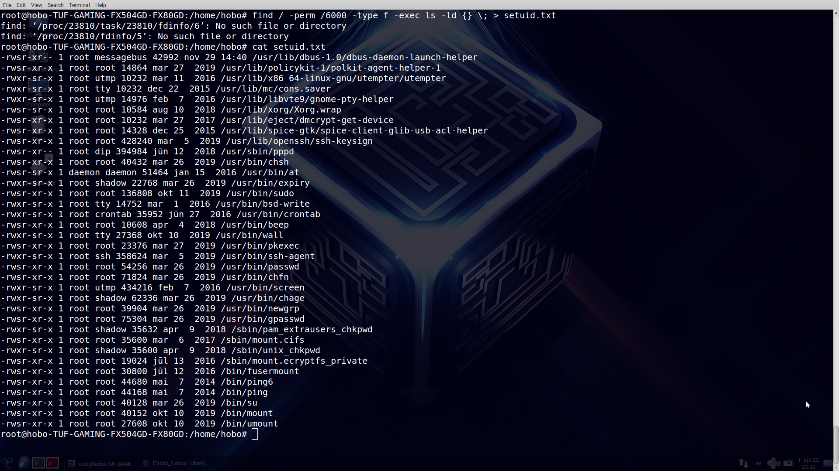

Parameters and meaning of them:

-perm -searching Linux’s files by access-mode.

6000 – binary value of rights

-type -f – kind of objects and files-kind for searching

-exec – key for executing operations with file. For this example there are output of full info about files in above directories.

**4.5.2.** Soft link – special file, which has link according needful file. Moving file to other directory will not change link to according one.

Hard link – every file has identifier. Name of file stays in “index-file” . Moving file is not “awful”.

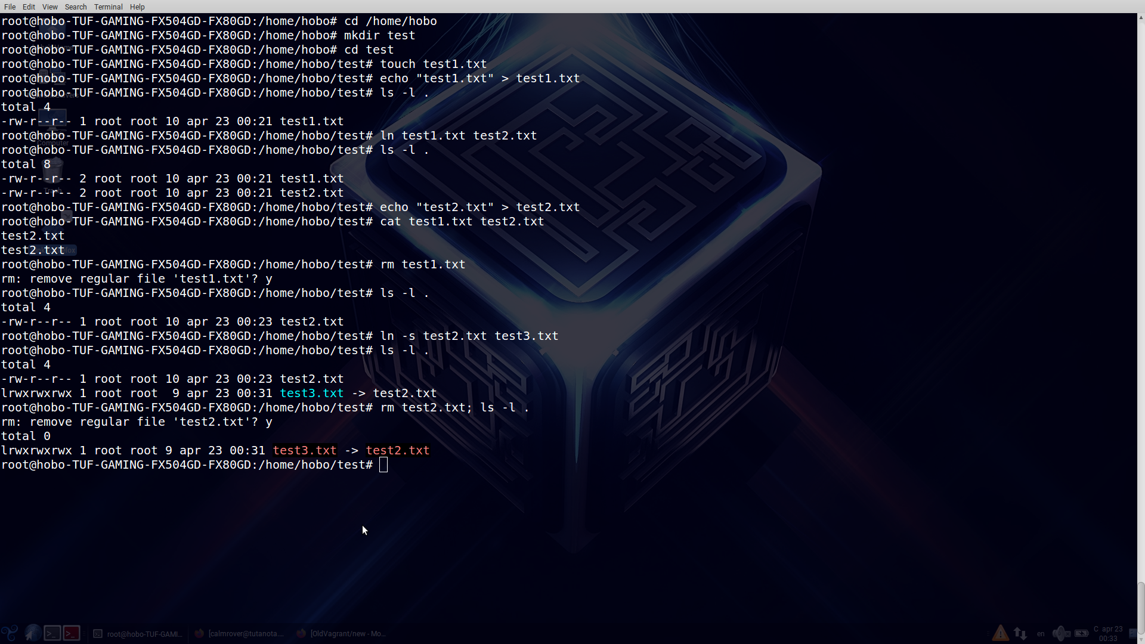

Explanation:

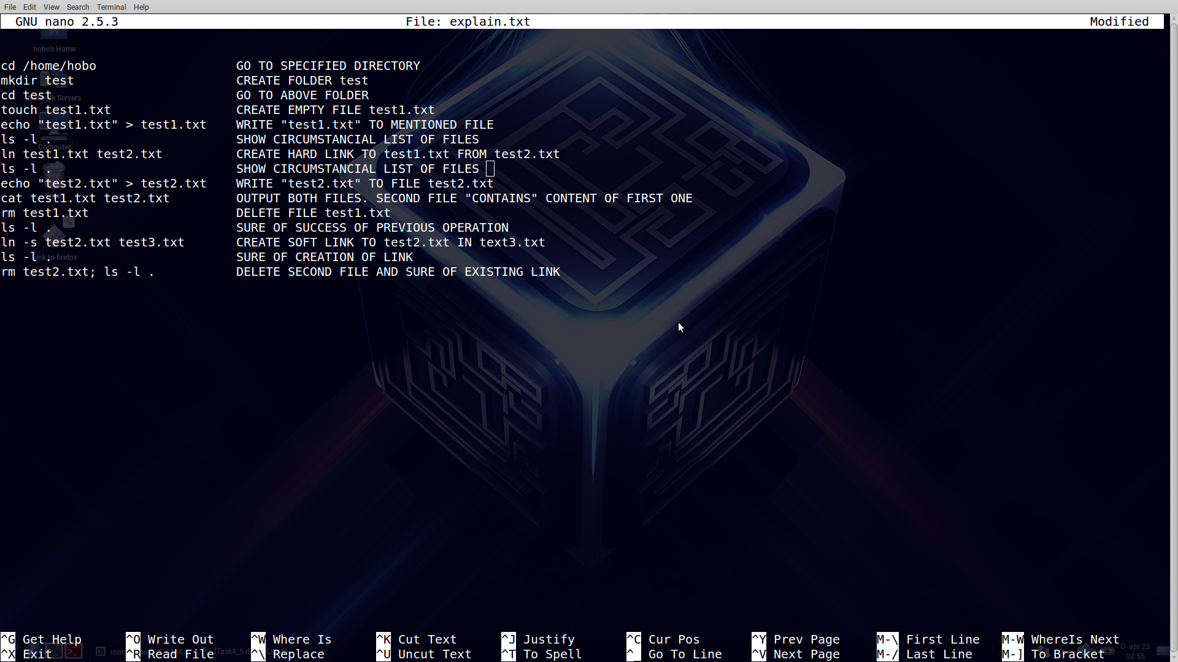

4.5.3

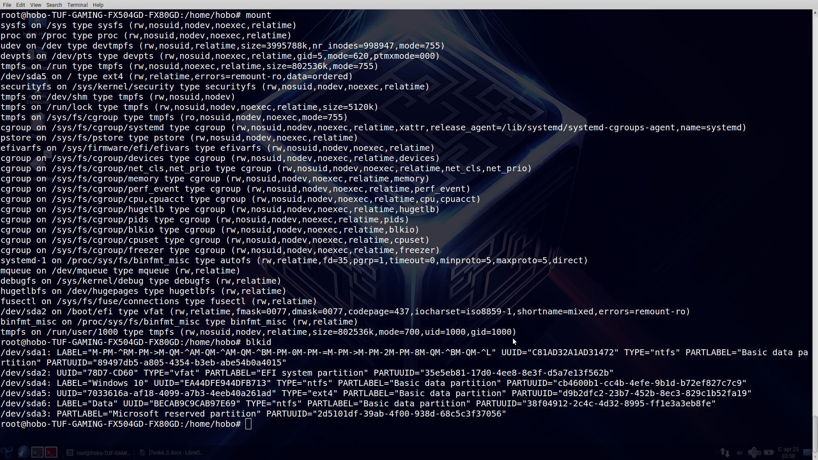

mount – info about divisions and mounted devices

blkid – showing UUID for our division

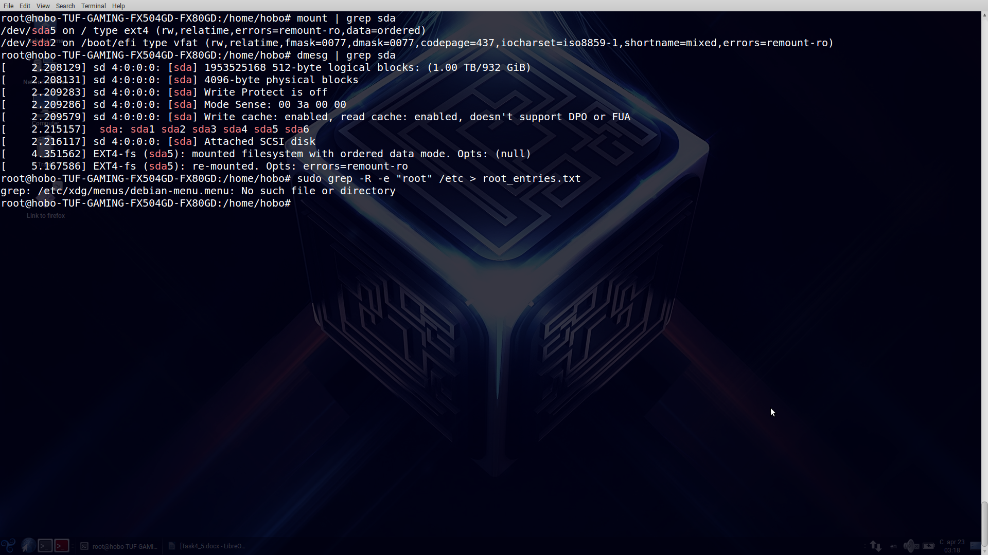showing info about file system of division of hard disk.

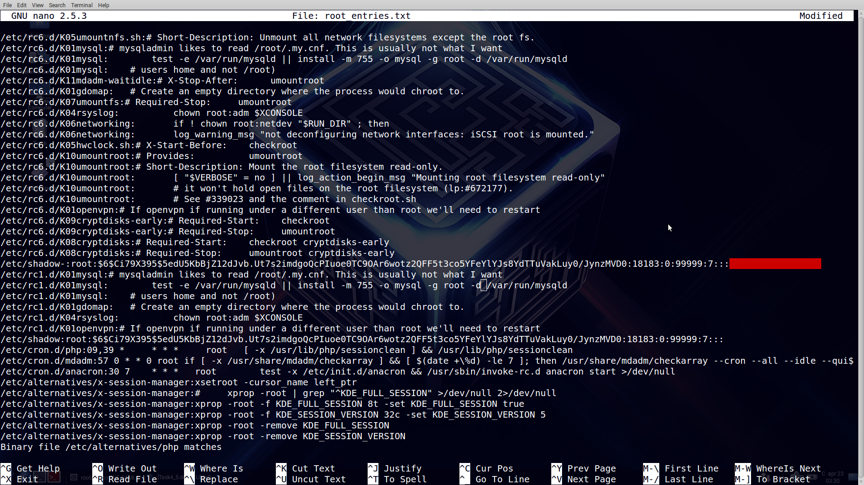

Hash of password for root